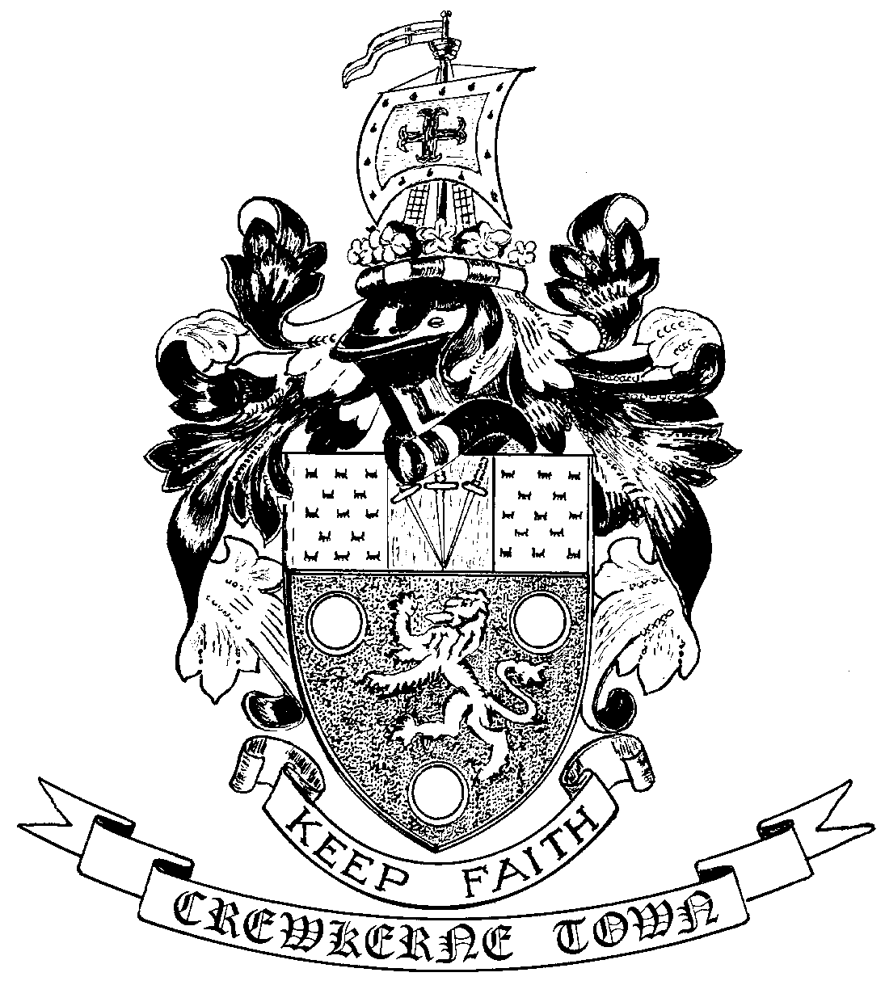
CREWKERNE TOWN COUNCIL

TOWN HALL
MARKET SQUARE
CREWKERNE
SOMERSET TA18 7LN
TEL: 01460 74001
EMAIL: towncouncil@crewkerne-tc.gov.uk

Town Clerk:
Mr P Davidson
Notice of a public meeting
THE ANNUAL TOWN MEETING OF ELECTORS
To be held on Monday 16 April 2018
in the Victoria Hall, Market Square at 7.30 pm

A G E N D A

- Introduction by Cllr. Ben Hodgson, the Mayor.
- Annual Citizenship Award presentation.
- Introduction of Town Councillors.
- To approve minutes of last Annual Town Meeting on 20 March 2017
- Any matters arising from these minutes.
- The Mayor’s Report of Crewkerne Town Council by Cllr. Ben Hodgson.
- Crewkerne Aqua Centre: a report from Claire Saxby, Director of CLM.
- The Henhayes Centre: a presentation from Rosemary Prince, Chair of Trustees.
- Life and death in Crewkerne: a presentation by the Town Clerk, based upon the burial records from the Townsend cemetery.
- Presentation of grants cheques to local groups and organisations
- Matters raised by Crewkerne residents
(It would be helpful to have advance notice of questions regarding financial matters)

Tea and coffee will be served

Councillors will be available to speak to Crewkerne residents about town affairs

All welcome

…………………………………………………

Cllr. Ben Hodgson, Mayor of Crewkerne
4 April 2018

